

File Selector Widget

Project Implementation

Connect5 Design

Table of Contents

Overview 3

Components 3

Components Sequence 4

Sample Request 4

Sample Response 5

Custom Implementation 5

Hook Points 6

Portal Implementation 6

Components 6

Steps 6

Screens 7

Overview

As part of substrate, a multi-select file upload widget will be available to allow users to upload multiple files for a single transaction. This functionality will alleviate the need for users to zip up PDFs before uploading to Substrate.

### Components

* JSP:
  + fileselector.jsp – presentation of upload form.
  + launch.jsp – auto redirect to URL.
* JavaScript:
  + fileselector.js – validates upload form.
* Style:
  + substrate.css – styles upload form.
* Java Source:
  + AbstractRequestHelper.java – base class for all request helpers.
  + FileUploadServlet.java – processes upload form.
  + RequestHelper.java – extensible request handler.
  + FileUploadFilter.java – manages request and session attributes.
* Properties:
  + upload.properties – configures file sector widget.

|  |  |
| --- | --- |
| **Property Name** | **Property Value** |
| file_upload_helper_classname | com.agencyport.substrate.fileupload.RequestHelper |
| ac_turnstile_req_template_path | ${context_path}/WEB-INF/upload/ac_turnstile_rq_template.xml |
| max_file_size | 20480 |
| file_temp_directory | ${context_path}/WEB-INF/temp |
| max_connection_read_timeout | 0 |
| ws.from.address | http://www.source-client.com/Agent/ClientOne |
| ws.replyto.address | http://www.w3.org/2005/08/addressing/anonymous |
| ws.action | http://www.agencyport.com/PC_Surety/ACORD1/PolicyQuote/CommlPkgPolicyQuoteInqRq |
| ws.to | http://dev-app07:9098/substrate/http-post/PolicyQuote |
| ws.clientapp.org | Carrier |
| ws.clientapp.name | AgencyPortal |
| ws.clientapp.version | 1.0 |
| com.agencyport_CompanyURL | com.agencyport.company.URL |

### Components Sequence

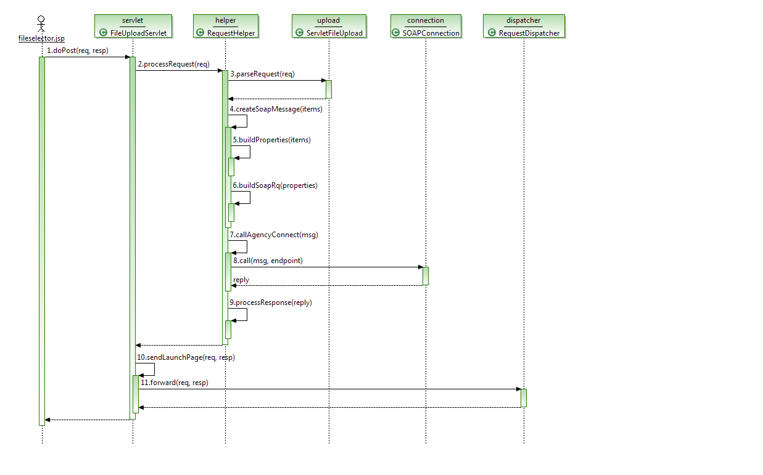

### Sample Request

<soap:Envelope xmlns:soap="http://www.w3.org/2003/05/soap-envelope" xmlns:xs="http://www.ACORD.org/standards/PC_Surety/ACORD1/XMLSchema">

<soap:Header xmlns:wsa="http://www.w3.org/2005/08/addressing">

<wsa:From>

<wsa:Address>http://www.source-client.com/Agent/ClientOne</wsa:Address>

<wsa:ReferenceParameters>

<xs:ClientApp>

<xs:Org>Carrier</xs:Org>

<xs:Name>AgencyPortal</xs:Name>

<xs:Version>1.0</xs:Version>

</xs:ClientApp>

<xs:SessKey> 4JoADj8wzfP4hOSTbvLKdx/mp5dU AIakN dQkQwcYwzHlLOqXfMBsPYj3N CLs/dVxmMkk5R Ij8MIT7hkwoZPgP1jLU1/</xs:SessKey>

</wsa:ReferenceParameters>

</wsa:From>

<wsa:Action>http://www.agencyport.com/PC_Surety/ACORD1/PolicyQuote/CommlPkgPolicyQuoteInqRq</wsa:Action>

<wsa:ReplyTo>

<wsa:Address>http://www.w3.org/2005/08/addressing/anonymous</wsa:Address>

</wsa:ReplyTo>

<wsa:MessageID>8A051352-B0A2-C6F6-DA82-D622FD09F9B5</wsa:MessageID>

<wsa:To>http://dev-app07:9098/substrate/http-post/PolicyQuote</wsa:To>

</soap:Header>

<soap:Body>

<CommlPkgPolicyQuoteInqRq xmlns="http://www.ACORD.org/standards/PC_Surety/ACORD1/XMLSchema">

<RqUID>8A051352-B0A2-C6F6-DA82-D622FD09F9B5</RqUID>

</CommlPkgPolicyQuoteInqRq>

</soap:Body>

</soap:Envelope>

### Sample Response

<soap:Envelope xmlns:soap="http://www.w3.org/2003/05/soap-envelope" xmlns:wsu="http://docs.oasis-open.org/wss/2004/01/oasis-200401-wss-wssecurity-utility-1.0.xsd" xmlns:wsse="http://docs.oasis-open.org/wss/2004/01/oasis-200401-wss-wssecurity-secext-1.0.xsd" xmlns:wsa="http://www.w3.org/2005/08/addressing" xmlns:datetime="http://exslt.org/dates-and-times">

<soap:Header>

<wsa:Action>http://www.agencyport.com/PC_Surety/ACORD1/PolicyQuote/CommlPkgPolicyQuoteInqRs</wsa:Action>

<wsa:MessageID>C536C1F8-961B-B174-1C69-B3A641A30388</wsa:MessageID>

<wsa:To>http://www.source-client.com/Agent/ClientOne</wsa:To>

<wsa:From>

<wsa:Address>http://dev-app07:9098/substrate/http-post/PolicyQuote</wsa:Address>

<wsa:ReferenceParameters>

<xs:ClientApp xmlns:xs="http://www.ACORD.org/standards/PC_Surety/ACORD1/XMLSchema">

<xs:Org>Agencyport</xs:Org>

<xs:Name>Substrate</xs:Name>

<xs:Version>1.0</xs:Version>

</xs:ClientApp>

</wsa:ReferenceParameters>

</wsa:From>

<wsa:RelatesTo>8A051352-B0A2-C6F6-DA82-D622FD09F9B5</wsa:RelatesTo>

<wsse:Security>

<wsu:Timestamp>

<wsu:Created>2012-05-17T11:13:43-04:00</wsu:Created>

</wsu:Timestamp>

</wsse:Security>

</soap:Header>

<soap:Body>

<CommlPkgPolicyQuoteInqRs xmlns="http://www.ACORD.org/standards/PC_Surety/ACORD1/XMLSchema">

<RqUID>8A051352-B0A2-C6F6-DA82-D622FD09F9B5</RqUID>

<TransactionResponseDt>2012-05-17T11:13:43-04:00</TransactionResponseDt>

<CurCd/>

<MsgStatus>

<MsgStatusCd>Success</MsgStatusCd>

</MsgStatus>

<com.agencyport.Carrier.URL> <http://localhost:8080/portal/FrontServlet?TRANSACTION_NAME=commlAuto&amp;PAGE_NAME=generalInfo&amp;METHOD=Display&amp;FIRST_TIME=true&amp;UPLOAD_SITUATION=YES&amp;ConversionGUID=E1E63BB2-2D36-A2D7-7B46-00A49EF71406&amp;WORKITEMID=1018&amp;FAST_FORWARD_TO=generalInfo&amp;rand=0.9307633101301971> </com.agencyport.Carrier.URL>

<com.agencyport.Carrier.Text>Carrier Decision Point</com.agencyport.Carrier.Text>

<com.agencyport.Carrier.AutoLaunch>1</com.agencyport.Carrier.AutoLaunch>

</CommlPkgPolicyQuoteInqRs>

</soap:Body>

</soap:Envelope>

## Custom Implementation

The default implementation will replace all variables found in the XML file specified by the property “ac_turnstile_req_template_path”. This XML can be updated to include new variables and the system will automatically replace them based on the matching form field name or request parameter.

RequestHelper is the main class that sends the soap request to the web-service and handles the SOAP response for the client. Projects that would like to override the default behavior can define that subclass to be used using the property “file_upload_helper_classname”.

|  |  |
| --- | --- |
| **Property Name** | **Property Value** |
| file_upload_helper_classname | com.company.CustomRequestHelper |

### Hook Points

* postBuildRequest(SOAPMessage msg)
  + Custom classes can change the soap message by overriding this method. The XML can be changed in this method to add more data to request.
* processResponse(SOAPMessage reply)
  + Custom classes can override this method if they would like to handle the response differently

## Portal Implementation

Project teams have to take the following steps to incorporate multi-select file upload UI into their applications.

### Components

* fileupload.jsp:
  + contains the anchor link and iframe definition.
* fileupload.js:
  + js function that opens the new dialog and sets the source url for iframe.
* (*) FileUploadURLGenerator.java:
  + Generates the URL for upload page with security token appended
* (*) web.xml:
  + Add entry for FileUploadURLGenerator servlet.

(*) Optional changes; needed if security is required between Portal and AgencyConnect

**Configuration**

The following properties should be updated to configure the File Upload URL; used to show the File Selector User Interface.

|  |  |
| --- | --- |
| **Property** | **Default Value** |
| FILE_UPLOAD_URL | /connect5/upload/FileSelector |
| APPEND_USER_CREDENTIALS_TO_RETURN_URL | true |
| ENCRYPT_USER_CREDENTIALS | true |

### Steps

1) Include the above portal artifacts provided.

2) If security between portal and connect is required, change the SubstrateURLGenerator.java to pass the appropriate security token to substrate. Sample implementation encrypts the userid and password into a token and passes it along with the url.

If security is not required, you can pass in the userid as part of the request.

3) Add the required entries to web.xml

<servlet>

<description>Servlet that generates agencyconnect url with credentials</description>

<display-name>FileUploadURLGenerator</display-name>

<servlet-name>FileUploadURLGenerator</servlet-name>

<servlet-class>com.agencyport.shared.servlets.FileUploadURLGenerator</servlet-class>

</servlet>

<servlet-mapping>

<servlet-name>FileUploadURLGenerator</servlet-name>

<url-pattern>/FileUploadURLGenerator</url-pattern>

</servlet-mapping>

### Screens

1) Portal screen with file upload link:

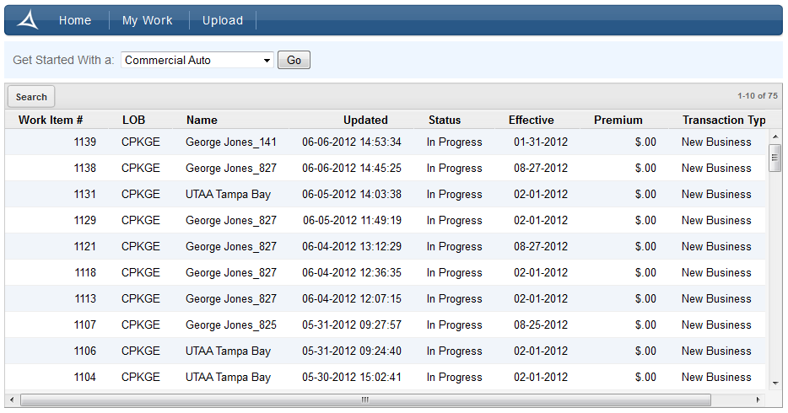

2) File selection window opens; user should attach files and click upload

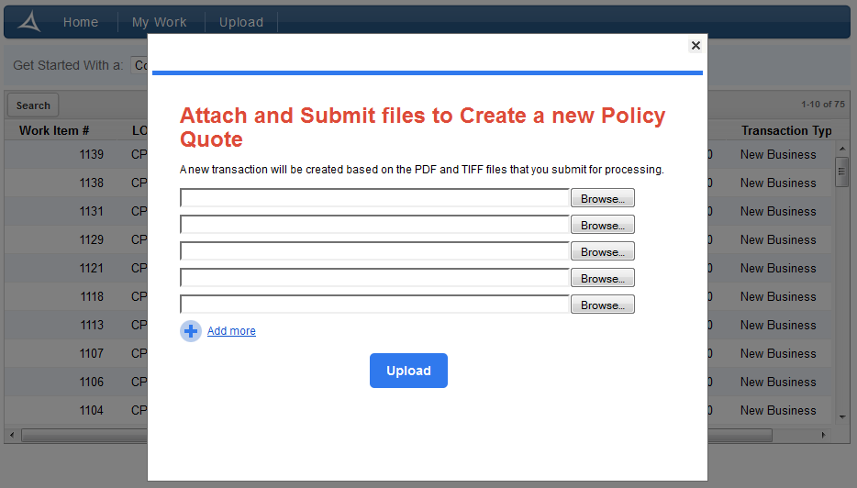

3) If call succeeds, file selection window is closed and work item upload window will open.

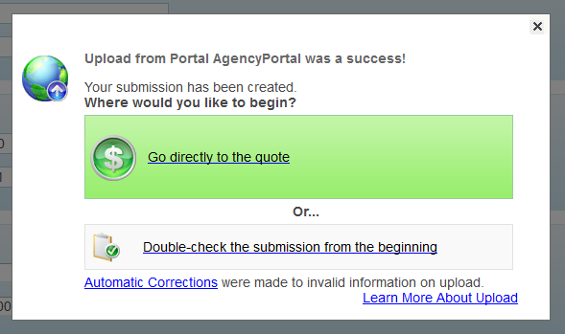

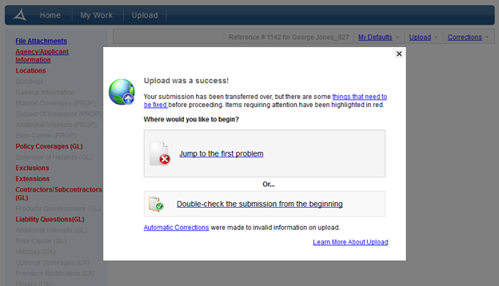

If call fails, error message is displayed on the same window.

